Concussion Policy and Code Preamble
- This policy is based on the 6th Consensus Statement on Concussion in Sport released in June 2023, and Rowan’s Law.
- Rowan’s Law imposes three obligations on sporting organizations in Ontario:
  - Receive an acknowledgement from Organizational Participants who are under 26 years of age, parents of athletes under 18, as well as their coaches, team trainers (including Athlete Support Personnel) and officials that they have reviewed Ontario’s concussion awareness resources;
  - Establish a Concussion Code of Conduct; and
  - Establish a removal-from-sport and return-to-sport protocol.
Esport Canada recognizes that Ontario’s Rowan’s Law is the leading standard in concussion prevention and awareness in Canada, and it is reflected within this Concussion Policy and Code (Policy). Esport Canada’s removal-from-sport and return-to-sport protocols are referred to as removal-from-participation and return-to-participation.
- This Policy also incorporates the report of the 2022 Concussion in Sport Group (2022 CISG), a group of sport concussion medical practitioners and experts, which provided recommendations for preventing concussions, These include implementing laws and protocols for mandatory removal from play following actual or suspected concussion; requirements to receive clearance for return-to-play from a healthcare provider; and education of coaches, parents and athletes regarding concussion signs and symptoms. These are associated with a reduction in recurrent concussion rates.
- A concussion is a clinical diagnosis that can only be made by a physician. The 2022 CISG defined sport-related concussion, in part as:
…a traumatic brain injury caused by a direct blow to the head, neck or body resulting in an impulsive force being transmitted to the brain that occurs in sports and exercise-related activities… Symptoms and signs may present immediately, or evolve over minutes or hours, and commonly resolve within days, but may be prolonged […] Sport-related concussion results in a range of clinical symptoms and signs that may or may not involve loss of consciousness.
- Timely recognition and removal, proper assessment and appropriate management are linked to faster recovery and improved outcomes following concussions.
Purpose
- Esport Canada believes that increased awareness of concussions and their long-term effects, as well as prevention of concussions is paramount to protecting the health and safety of Organizational Participants.
- This Policy applies to all activities and events for which Esport Canada is the governing or sanctioning body including, but not limited to, competitions, practices, and training sessions.
Definitions
- This Policy defines the following terms:
  - Athlete Support Personnel: Any coach, trainer, manager, agent, team staff, official, medical, paramedical personnel, parent, or any other person working with, treating or assisting a Player participating in or preparing for sports competition.
  - Designated Person: Refers to a person/people designated by Esport Canada removal-from-sport protocol and by its return-to-sport protocol for the purposes of fulfilling various duties indicated in this Policy. The Designated Person(s) is/are responsible for ensuring that:
    - an athlete is immediately removed from further training, practice or competition if the athlete is suspected of having sustained a concussion,
    - if the athlete is under 18 years of age or such other age as may be prescribed, the parent or guardian is informed of the removal,
    - such persons or entities as may be prescribed are informed of the removal, and
    - once removed, the athlete is not permitted to return to training, practice or competition, except in accordance with Esport Canada’s Return-to-Sport protocol.
  - Organizational Participant: includes Players, Athlete Support Personnel, and other Organizational Participants as defined in Esport Canada’s By-Laws and policies.
  - Player : An individual who is a Player Participant in Esport Canada who is subject to the By-Laws and policies of Esport Canada.

  - Qualified Healthcare Professional: Refers to a licensed health care professional who has been trained in concussion assessment and treatment.
  - Return-to-Participation (RTP): Adapted from the “Return-to-Sport” strategy; completion of the RTP strategy with no symptoms and no clinical findings associated with the current concussion at rest and with maximal physical exertion.
Registration
- When an Organizational Participant under the age of 26 years old registers with Esport Canada, the Organizational Participant must provide written or electronic confirmation (sign) that they have reviewed concussion awareness resources within the past 12 months, pursuant to Rowan’s Law. The Ontario Government has produced age-appropriate concussion resources:
  - Ages 10 and under
  - Ages 11-14
  - Ages 15+
- Organizational Participants under the age of 26 years old must also sign the Concussion Code of Conduct (Appendix A, Part A).
- For Organizational Participants younger than 18 years old, their parent or guardian must also provide confirmation that they have also reviewed the concussion resources as well and signed the Concussion Code of Conduct.
- Athlete Support Personnel must provide confirmation that they have also reviewed the concussion resources and sign the Concussion Code of Conduct (Appendix A, Part B); but not if they will be interacting exclusively with Organizational Participants who are 26 years old or older.
- While Rowan’s Law mandates Organizational Participants and Athlete Support Personnel under 26 years of age in Ontario to sign the Concussion Code of Conduct, Esport Canada also requires that those over the age of 26 familiarize themselves with relevant concussion information and sign on the Concussion Code of Conduct.
Removal from Participation Protocol: Recognizing Concussions
- Although the formal diagnosis of concussion should be made following a medical assessment, all sport stakeholders including athletes, parents, teachers, coaches, officials, and Qualified Healthcare Professionals are responsible for the recognition and reporting of athletes who may demonstrate visual signs of a head injury or who report concussion-related symptoms. Some sport and recreation venues will not have access to on-site Qualified Healthcare Professionals.
- A concussion should be suspected:
  - in any Player who sustains a significant impact to the head, face, neck, or body and demonstrates ANY of the visual signs of a suspected concussion or reports ANY symptoms of a suspected concussion as detailed in the Concussion Recognition Tool (see Appendix “B”); and/or
  - if a Player reports ANY concussion symptoms to one of their peers, parents, teachers, or coaches or if anyone witnesses a Player exhibiting any of the visual signs of concussion.
Note that the physical implications outlined in Section 15(a) may arise from, for example, falling from gaming chairs, hitting equipment or other physical impacts to the head sustained by the Player while competing in an Esport Canada Event.
- Concussions can be identified with the help of the Concussion Recognition Tool, 6th Edition (“CRT6”), Appendix “B”. As the CRT6 is updated and new versions are implemented, Esport Canada will update this Policy.
- If an ambulance is called involving a minor Organizational Participant, the parent/guardian and/or emergency contact of the minor Organizational Participant must be contacted immediately to inform them.

Removal from Sport Protocol: Steps and Process
- Removal of an Organizational Participant from competition should be done by the Designated Person(s) if there is suspicion of a possible concussion. This Person is either:

  - An on-site Esport Canada staff member; and/or

  - The Designated Person for the Event.
Esport Canada will identify the Designated Person(s).

- Recognition and removal from sport are actions that should be taken following reference to the CRT6 (Appendix B) The CRT6 is provided as a tool that non-medically trained personnel can use (i.e., the Designated Person(s)) for the identification and immediate management of a suspected concussion. It is not used to diagnose a concussion.
- Following the removal of any Organizational Participant on the basis of a suspected concussion:
  - the Designated Person(s) who removed the Organizational Participant must call 9-1-1 if, in the Designated Person’s opinion, doing so is necessary;
  - Esport Canada must create and keep a record of the removal;
  - The Designated Person(s) must inform the Organizational Participant’s parent or guardian of the removal if the Organizational Participant is younger than 18 years old, and inform the parent or guardian that the Organizational Participant is required to undergo a medical assessment by a Qualified Healthcare Professional before the Organizational Participant will be permitted to return to participation; and
  - The Designated Person(s) will remind the Organizational Participant, and the Organizational Participant’s parent or guardian as applicable, of Esport Canada’s Removal from Sport and Return-to-Sport protocol as described in this Policy.
- If an Organizational Participant is suspected of sustaining a concussion but there is no concern for a more serious head or spine injury (i.e., no red flags as indicated in the CRT6), they should be immediately removed from the field of play, and proceed as follows:

  - If a Qualified Healthcare Professional is present, the Organizational Participant should be taken to a quiet area and undergo sideline medical assessment.

  - If a Qualified Healthcare Professional is not present, the Organizational Participant should be referred for medical assessment by a Qualified Healthcare Professional as soon as possible. They must not return to play until medical clearance is received.

- Once an Organizational Participant is assessed medically, and:

  - is determined to not have not sustained a concussion, they must provide a Medical Assessment Letter indicating this. The Organizational Participant can return to sport activities without restriction.
  - is diagnosed with a concussion, they should be provided with a Medical Assessment Letter indicating this. The Organizational Participant may return in accordance with the Return-to-Sport Protocol in this Policy.
Return-to-Participation (RTP) Protocol
- The table below contains the RTP Protocol which is a requirement of Rowan’s Law (as adapted from the “Return-to-Sport” terminology), once medical clearance has been received.
Stage | Aim | Activity | Stage Goal
1 | Activities of daily living and relative rest (first 24 to 48 hours) | Daily activities that do not exacerbate symptoms | Gradual reintroduction of work/school activities; no screen time, except as essential
After a maximum of twenty-four (24) to forty-eight (48) hours after injury, progress to Step 2
2A | Light activities | Light aerobic exercise, such as stationary cycling or walking at slow to medium pace.  Brief screen time with no symptom worsening occurring  Take breaks and modify activities as needed | No symptom worsening
3 | Organizational Participant esport-specific activities, without risk of inadvertent head impact with school accommodations (as needed) | Add sport-specific activities  Perform activities individually and under supervision from a teacher, parent/caregiver, or coach  Gradually increase tolerance and intensity of activities by increasing the cognitive load (i.e., short gaming sessions)  Progress to where athlete is free of concussion-related symptoms, even when exercising | Tolerating screen time for 30-60 minutes without symptom worsening
Medical clearance
If the Organizational Participant has been medically cleared, progress to Step 4.
4 | Non-competitive gaming; return to all non-competitive activities, full practices | Progress to practice mode while gaming, or coaching capacities | Resume usual intensity of activities, coordination, and activity-related cognitive skills.
If the Organizational Participant can tolerate usual intensity of activities with no return of symptoms, progress to step 5.
5 | Return to participation | Normal, unrestricted participation in scrims, full matches.  Full recovery is verified by a physician. | Return to activities that have full screen time and concentration required, restore confidence and assess functional skills by coaching staff
- The Organizational Participant’s RTP strategy should be guided and approved by a physician with regular consultations throughout the process. Specifically, progression through the later RTP strategy (Steps 4–5) should be monitored by a health care professional.
- To fully return to participation, the affected Organizational Participant must provide Esport Canada with a medical clearance form, signed by a physician, following Stage 4 and before proceeding to Stage 5.
- Additional consultation with a Qualified Healthcare Professional is recommended if there is recurrence of symptoms when progressing through RTP strategies.
Administrative Responsibilities
- Esport Canada will provide a form template for Members to track injury incidence (Appendix E). Members are responsible for monitoring injury incidence.
- Members must maintain records of reported and suspected concussions and documentation of Participant diagnosis and clearance to return to play.
- Tournament organizers must document all suspected and actual concussions.
- Copies of all Medical Assessment Letters and Medical Clearance Letters must be securely stored.
- Esport Canada will collect aggregate injury statistics to monitor and refine safety practices.
- Esport Canada will conduct a review of this policy annually.
Non-Compliance
- Failure to abide by any of the guidelines and/or protocols contained within this policy may result in disciplinary action in accordance with Esport Canada’s policies for Discipline and Complaints.
Not Advice
- Nothing in this Policy is to be interpreted as medical or legal advice.
Appendix A - Concussion Code of Conduct
PART A
The following section of the Concussion Code of Conduct must be signed by all Organizational Participants under the age of 26 years old. For Organizational Participants who are younger than the age of majority in the applicable territory, a parent/guardian must also sign this section.
I will help prevent concussions by:
- wearing the proper equipment for my sport and wearing it correctly;
- developing my skills and strength so that I can participate to the best of my ability;
- respecting the rules of my sport or activity;
- demonstrating my commitment to fair play and respect for all (respecting other athletes, coaches, team trainers and officials).
I will care for my health and safety by taking concussions seriously, and I understand that:
- a concussion is a brain injury that can have both short-term and long-term effects;
- a blow to my head, face or neck, or a blow to the body that causes the brain to move around inside the skull may cause a concussion;
- I don’t need to lose consciousness to have had a concussion;
- I have a commitment to concussion recognition and reporting, including self-reporting of possible concussion and reporting to a designated person when and an Organizational Participant suspects that another Organizational Participant may have sustained a concussion. (Meaning: If I think I might have a concussion I should stop participating in further training, practice, or competition immediately, and I will tell an adult if I think another athlete has a concussion);
- continuing to participate in further training, practice or competition with a possible concussion increases my risk of more severe, longer lasting symptoms, and increases my risk of other injuries;
- I have a commitment to zero-tolerance for prohibited play that is considered high-risk for causing concussions;
- I acknowledge that mandatory expulsion from competition may occur for violating zero-tolerance for prohibited play that is considered high-risk for causing consequences; and
- I acknowledge that there are escalating consequences for those who repeatedly violate this Concussion Code of Conduct.
I will not hide concussion symptoms. I will speak up for myself and others.
- I will not hide my symptoms. I will tell a coach, official, team trainer, parent or another adult I trust if I experience any symptoms of concussion.
- If someone else tells me about concussion symptoms, or I see signs they might have a concussion, I will tell a coach, official, team trainer, parent or another adult I trust so they can help.
- I understand that, if I have a Suspected Concussion, I will be removed from sport and that I will not be able to return to training, practice or competition until I undergo a medical assessment by a medical doctor or nurse practitioner and have been medically cleared to return to training, practice or competition.
- I have a commitment to sharing any pertinent information regarding incidents of removal from sport with my school and any other sport organization with which I have registered. (Meaning: If I am diagnosed with a concussion, I understand that letting all of my other coaches and teachers know about my injury will help them support me while I recover.)
I will take the time I need to recover because it is important for my health.
- I understand my commitment to supporting the return-to-sport process and I will follow my sport’s Return-to-Sport Protocol.
- I understand I will have to be medically cleared by a medical doctor or nurse practitioner before returning to training, practice or competition.
- I will respect my coaches, team trainers, parents, health-care professionals, and medical doctors and nurse practitioners, regarding my health and safety.
By signing here, I acknowledge that I have fully reviewed and commit to this Concussion Code of Conduct.

______________________ _________________________ _______________
Name of Organizational Signature of Organizational Date
Participant (Print) Participant

______________________ _______________________ _______________
Name of Parent or Signature of Parent or Date
Guardian (print) Guardian

PART B
The following section of the Concussion Code of Conduct must be signed by all coaches and team trainers who interact with Organizational Participants under the age of 26 years old.
I can help prevent concussions through my:
- efforts to ensure that my athletes wear the proper equipment and wear it correctly;
- efforts to help my athletes develop their skills and strength so they can participate to the best of their abilities;
- respect for the rules of my sport or activity and my efforts to ensure that my athletes do too; and
- commitment to fair play and respect for all (respecting other coaches, team trainers, officials and all Organizational Participants and ensuring my athletes respect others and play fair).
I will care for the health and safety of all Organizational Participants by taking concussions seriously. I understand that:
- a concussion is a brain injury that can have both short-term and long-term effects;
- a blow to the head, face, or neck, or a blow to the body may cause the brain to move around inside the skull and result in a concussion;
- a person doesn’t need to lose consciousness to have had a concussion;
- an Organizational Participant with a Suspected Concussion should stop participating in training, practice or competition immediately;
- I have a commitment to concussion recognition and reporting, including self-reporting of possible concussion and reporting to a designated person when an Organizational Participant suspects that another Organizational Participant may have sustained a concussion;
- continuing to participate in further training, practice or competition with a Suspected Concussion increases a person’s risk of more severe, longer lasting symptoms, and increases their risk of other injuries or even death;
- I acknowledge that there are escalating consequences for those who repeatedly violate this Concussion Code of Conduct.
I will create an environment where Organizational Participants feel safe and comfortable speaking up. I will:
- encourage athletes not to hide their symptoms, but to tell me, an official, parent or another adult they trust if they experience any symptoms of concussion after an impact;
- lead by example. I will tell a fellow coach, official, team trainer and seek medical attention by a physician or nurse practitioner if I am experiencing any concussion symptoms;
- understand and respect that any athlete with a Suspected Concussion must be removed from sport and not permitted to return until they undergo a medical assessment by a physician or nurse practitioner and have been medically cleared to return to training, practice or competition.
- For coaches only: commit to providing opportunities before and after each training, practice and competition to enable athletes to discuss potential issues related to concussions.
I will support all Organizational Participants to take the time they need to recover.
- I understand my commitment to supporting the Return-to-Sport process.
- I understand the athletes will have to be cleared by a physician or nurse practitioner before returning to sport.
- I will respect my fellow coaches, team trainers, parents, physicians and nurse practitioners and any decisions made with regards to the health and safety of my athletes.

By signing here, I acknowledge that I have fully reviewed and commit to this Concussion Code of Conduct.

______________________ _________________________ _______________
Name and role (print) Signature Date

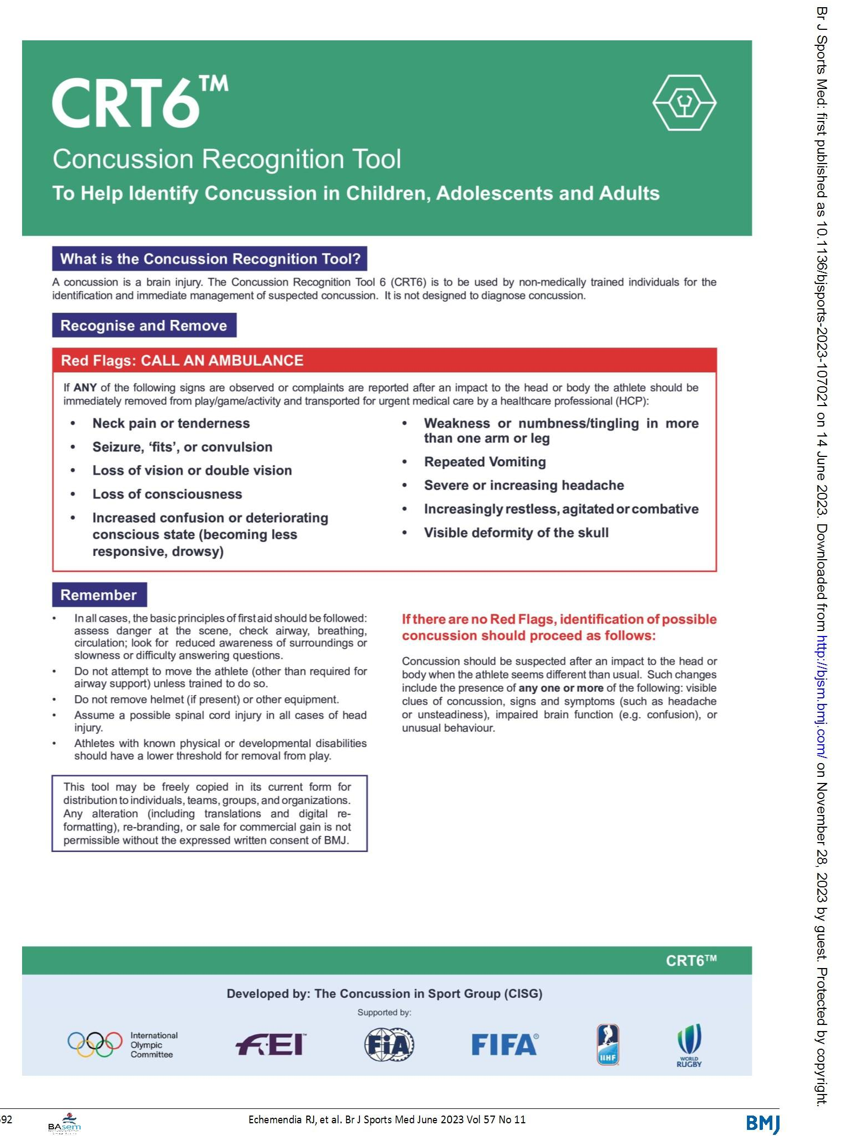
Appendix B – Concussion Recognition Tool 6 (CRT6)

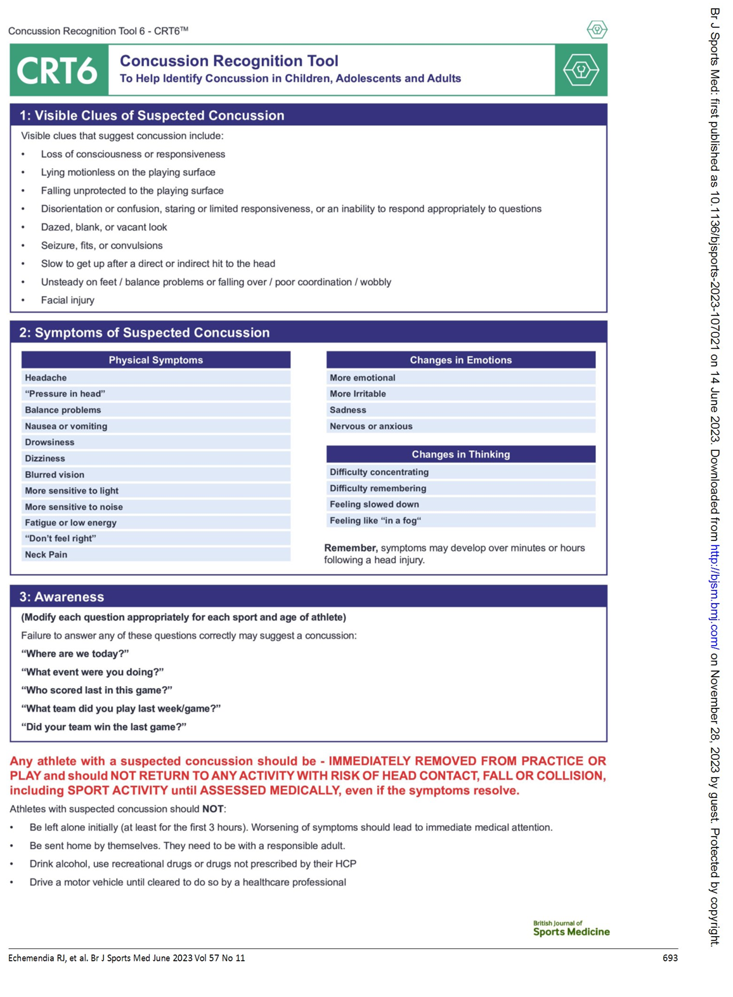
Appendix C – Sport Concussion Pathway
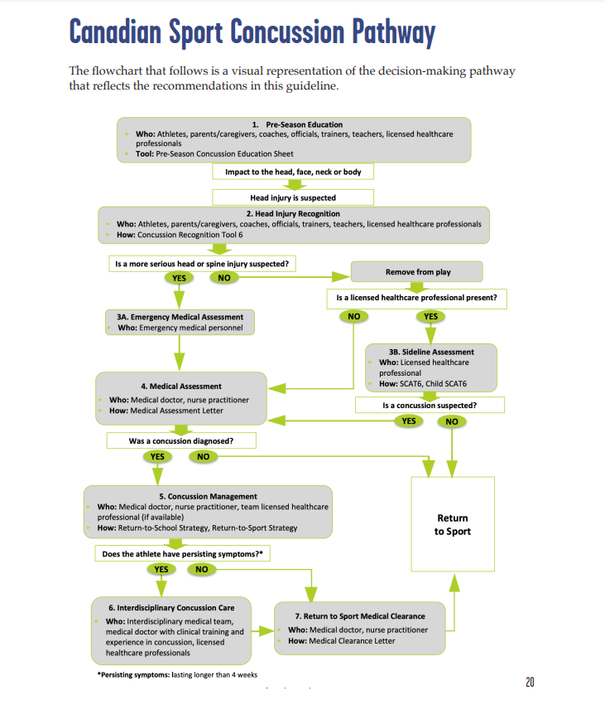

Appendix D – Key points from CISG Recommendations
Refine
- The 2022 CISG identified several areas of refinement to strengthen future consensus statements: Para Sport, Paediatrics, the Athlete’s Voice and Ethical Considerations, limitations, and improvements. The following are relevant for Esport Canada’s application of this policy.
Para Sport
- The concussion experience of the para-athlete is unique, due to the interaction of the Organizational Participant’s primary impairment and the pathophysiology of concussion. Para athletes require a more individualised approach when it comes to evaluating concussions.
- Esport Canada should be aware that prevention approaches, detection of initial symptoms, diagnosis, recovery (i.e., potential for persisting symptoms of concussion) and treatment strategies may be impacted by the characteristics of the Organizational Participant’s underlying impairment.
- Organizational Participants with visual impairment may be at even greater risk of concussion, as the mechanisms of injury in this population are primarily through collisions or direct head contact.
- The following considerations by the Concussion in Para Sport Group are important for Esport Canada to keep in mind when dealing with para-sport Organizational Participants:
  - Para-sport Organizational Participants may benefit from baseline testing given the variable nature of their disability and the potential for atypical presenting signs/symptoms of concussion;
  - Para-sport Organizational Participants with a history of central nervous system injuries (i.e., cerebral palsy, stroke) may require an extended period of initial rest;
  - testing for symptoms of concussion through recovery may require modification such as the use of arm ergometry as opposed to a treadmill/stationary bike; and
  - RTS protocols must be tailored and include the use of the individual’s personal adaptive equipment and, for applicable participants with visual impairment, partnership with their guide.
Paediatrics
- Child and adolescent athletes are less likely to have trained medical personnel available on the sidelines, and it is strongly recommended that the CRT6 be used by all adults supervising child and adolescent sport.
- Children and adolescents with repeat concussions wishing to continue to play or to progress to the next age-level group or elite pathway/national level programmes require individualised assessment.

Appendix “E” - Form template for Members to track injury incidence

(Concussion Safety) 2018, 2018 SO 2018, c. 1 (“Rowan’s Law”)
An Athlete must be removed by the Designated Person on the basis of a suspected concussion regardless of whether or not the concussion was sustained or is suspected to having been sustained during a sport activity associated with Esport Canada.
Athletes who have been diagnosed with a concussion can be considered for medical clearance to return to sport activities with risk of contact or fall once they have suSICsfully completed: Steps 1 to 3 of the sport-specific RTP strategy. To progress to Step 4 of RTS, the athlete must provide their coach with a Medical Clearance Letter that specifies that a medical doctor or nurse practitioner has personally evaluated the patient and has cleared the athlete to return to sport. In geographic regions of Canada with limited access to medical doctors (i.e., rural, remote, or northern communities), a Qualified Healthcare Professional (i.e. a nurse) with pre-arranged access to a medical doctor or nurse practitioner can provide this documentation.
In some cases, it may be in the best interest of the Athlete to discontinue their participation as a result of potential head injuries and concussions.

